Birth & Death Registration



Table of Contents
S.No | Topics | Page No
1. | Introduction | 4
2. | System Overview | 5
3. | Background | 5
4. | Stake Holders | 6
5. | Purpose of Birth Registration | 7
6. | Birth Registration Process | 7
7. | Child-Name inclusion for Birth Registration | 8
8. | Correction and Cancellation for Birth Registration | 9
9. | Date correction | 10
10. | Issue of Birth Certificate for single parent / unwed mother | 11
11. | Procedure for registration of birth of Orphan/abandoned children | 11
12. | Purpose of Death Registration | 12
13. | Death Registration | 13
14. | Death Registration of Missing Person | 15
15. | Still Birth | 15
16. | Roles and Responsibilities of Registrar for Birth & Death registration | 16
17. | Delayed Registration of Birth & Death | 19
18. | Registration of Adopted Child | 20
19 | Rules for Tamil Nadu Birth & Death Registration | 21
20. | Step by step Procedure for downloading Birth/Death certificates | 30

Document
Document History
Version # | Date | Authors | Comments
1.0 | 12.10.2023 | Ramya | Created document- Rechange initiated by client

- Introduction
Civil Registration System (CRS) primarily, is a web-based application as a common solution for Birth, Death and Still Birth Registration and Certificate generation across the country. System provides centralized data management of all recorded events for Birth and Death and Stillbirth registration. System also facilitates frequent reports for analysis and planning based on data of birth, death and stillbirth registration. System provides robust User management based on different user authorization to access and generate data and reports. Different users are provided access to application at different level of authorization and authentication. System provides secured access to users having user ID and password. A user having basic knowledge of computer and internet can work easily with application.
Civil Registration is defined as continuous, permanent, compulsory recording of the occurrence and characteristics of vital events, like births, deaths and still births. It provides a safeguard to social status and individual benefits among other benefits the system provides the individual with a unique identity (her/his name), records parental relationships and provides a statement of place of birth of the child and usually of one or both parents which are basic grounds on which nationality may be established, depending on laws of each country. The birth registration records are generally required for establishing proof of age for school entry, employment, obtaining a driving license, entering into legal contracts, marriage etc. The death registration record is generally required for settlement of inheritance, insurance claims, claiming family allowances and other social security benefits. For administrative purposes, the birth records are the basis for public health programmes for post-natal care of mother and child and for programmes of vaccination, immunisation etc. The death records are useful indicators of existence of infectious and epidemic diseases and the need for immediate control measures. The registration records can also be extensively used in medical research and in epidemiological and genetic studies. They can provide the frame for follow-back or follow up sample surveys. Compilation of detailed vital statistic has now become a major function of the civil registration system. The vital events and the related characteristics of the events provided at the time of registration readily lend themselves for compilation of continuous series of vital statistics. These statistics can be used for measuring population change on an annual basis, which otherwise cannot be obtained from Censuses it is only a periodic activity. In addition, the civil registration system can provide the vital statistics for very small geographical areas, a characteristic that no other data collection system can provide among other demographic uses of vital statistics are study of fertility and mortality and construction of life tables and preparation of projections. Vital statistics are invaluable for planning, monitoring and evaluating various programmes such as those dealing with primary health care, social security, family planning, maternal and child health, nutrition, education, education, public housing and so forth.
- System Overview
Birth/Death registration in Tamil Nadu should begin with a comprehensive system overview. This section provides an overview of the purpose and scope of the software system. It should include information about the stakeholders involved in the birth/death registration process, such as government authorities, medical professionals, funeral homes, and citizens. The system overview should also outline the key objectives of the software system, which may include improving data accuracy, reducing paperwork, enhancing accessibility, and ensuring timely registration.
- Background
In India the registration of births and deaths is carried out under provisions of the Registration of Birth and Death (RBD) Act, 1969 and governed by Tamil Nadu Registration of Birth and Death Rules, 1977. The revamped system of registration of births and deaths was implemented from 01.01.2000 as per Tamil Nadu Registration of Birth and Death Rules, 2000. The Director of Public Health and Preventive Medicine is appointed as the Chief Registrar of Births and Deaths in Tamil Nadu as per section 4 (3) of the RBD Act, 1969 and he is the implementing authority of the RBD Act 1969 in the State.
The District Registrar /Additional District Registrar is responsible for carrying into execution in the District, the provisions of this Act and the orders of the Chief Registrar issued from time to time for the purpose of this Act.
The registration of births and deaths is done by the local registrars appointed by the State Government under Section 7(1) of the RBD Act, under whose jurisdiction the event has taken place.

The Registration Hierarchy in Tamil Nadu is given below
- Chief Registrar of Births and Deaths (Director of public Health and Preventive Medicine
State Level
- Deputy Chief Registrar (Joint Director (SBHI))
- District Registrar (DRO)
- Additional District Registrar (DDHS)
District Level
- Joint District Registrar (AD(SBHI)
- Registrar Births and Deaths
- Stake Holders
The Stake Holders involved in Birth and Death registration are
- Revenue Administration
- Health Department
- Police Department
- All Municipal Administration (Corporation & Municipalities) under Government of Tamil Nadu
- Town Panchayats under Government of Tamil Nadu
- Village Panchayats under Government of Tamil Nadu
- Inspector General of Registration under Government of Tamil Nadu
- Printing and Stationaries under Government of Tamil Nadu
The registered data are duly shared with
- Registrar General of India
- UIDAI,
- Aadhaar,
- TNeGA,
- RGI,
- PICME,
- CM Dashboard,
- Social Welfare Department,
- Civil Supply Corporation
- Election Commission of India

- Purpose of Birth Registration
Birth registration in the Civil Registration System (CRS) is a vital process that ensures the legal recognition and documentation of a child's birth. It is a fundamental right of every child to be registered at birth, as recognized by international human rights standards. Birth registration serves as the foundation for establishing an individual's legal identity, nationality, and access to various rights and services throughout their life.
- Birth Registration Process
The births are reported at the place of occurrence of the event by the concerned institution/registrar under whom jurisdiction the event has taken place as per provision of Section 7 (2) of the RBD Act, 1969.
The institutional events cannot be reported by the family members, it is duty of the in-charge of the institution to report such events to concerned jurisdictional registrar.
In respect of birth occurred in a Hospital, Primary Health centre, Maternity or nursing home or other such Private Medical institutions, the medical officer In-charge or any person authorized by him in this behalf is responsible for reporting.
In respect of birth occurred in a house, it is the duty of the Head of the house/household or nearest relative of the head present in the house or in the absence of any such person, the oldest male person present therein during the said period is responsible to report the event to the concerned Registrar. These events can also be reported through the prescribed Notifiers such as Anganwadi Workers, ANM’s, ASHA’s and others.
The normal period of 21 days (from the date of occurrence) has been prescribed for reporting the birth, death and still birth events.
If event of birth is not reported for registration within 21 days, the same can be reported any time under the Delayed Registration provisions prescribed under Section 13 of the Act with payment of fee prescribed.
The concerned Registrars are to be approached at the place of occurrence of the event are
- Corporation - Sanitary Inspector
- Municipality, Township - Sanitary Inspector
- Town Panchayats - Executive Officer/ Sanitary Inspector
- Village Panchayats - Village Administrative Officer
- Primary Health Centres - Health Inspector
- Govt. Medical Institutions - Health Inspector
- Cantonment - Sanitary Inspector
- Estates / Plantations – Manager
- Child-Name inclusion for Birth Registration
The name of the child shall be registered within one year from the date of registration of the birth without any late fee. Beyond 1 year but within 15 years from the date of registration, the name of the child can be registered with a late fee of Rs. 200/-. Extension of 5 years period up to 31.12.2024 is provided to register the name for all the cases where the birth has been already registered and the above prescribed 15 years period got over. The declaration of Parents/Guardian is mandatory for name registration. The name once registered cannot be changed.
Registration of a birth can be done without the name of the child. A provision has been made in the State Rules enabling the Register to enter the name of the child in the register in respect of the birth already registered by him after getting the information from the parent or guardian of such child within a period of one year from the date of registration. The name of the child can also be entered even after one year on payment of prescribed late fee as per the provisions made in the State Rules
Registrar can include the child’s name using name inclusion option available in Registrar login for Birth registered records. Registrar of Births will enter the child name in the birth register and web portal by using the password. After verifying the details application will be accepted or rejected.
Name Inclusion Process
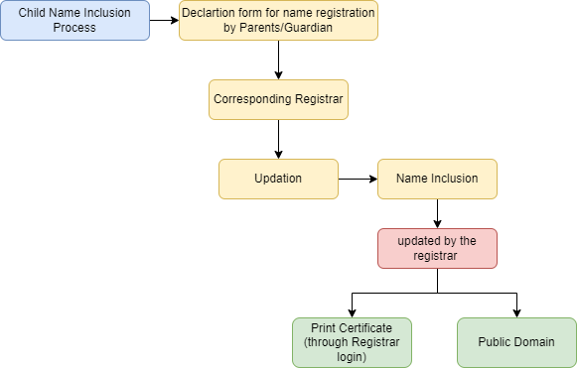

- Correction and Cancellation for Birth Registration
Corrections or Cancellations can be done by the jurisdictional Birth and Death Registrar alone under the provision of Section 15 of the RBD Act and as per rule 11 of Tamil Nadu registration of Birth and Death Rules, 2000. The changes made in the name of father/mother through Gazette notification or otherwise subsequent to the date of registration of birth of the child, could not be incorporated in the birth register.
Registrar can correct the records using correction option available in Registrar login for Birth records.
Rules have also been framed for corrections or cancellation of an entry in the register of births and deaths. The Registrar can correct or cancel any entry in the register, which is erroneous in from, or substance, subject to the provisions of these rules. The errors may be of different types:
- clerical or formal error
- error in substance
- fraudulent or improper entry.
The procedures to be followed in each case are as follows:
- Clerical or formal error: In this case the Registrar must inquire into the matter and satisfy himself that such an error has been made. She / He should correct the entry and send an extract of the entry showing the error and how it has been corrected to the State Government or the officer specified by it. If however, the register is not in her/his possession, then she/he must make report to the State Government or the officer specified by it and call for the register for enquiring in to the matter and making necessary correction in the register. In this case, the corrections would require countersigning by the specified authority.
- Error in substance: In this case the registrar can correct the entry upon production of declaration setting forth the nature of the error and the true facts of the case made by two credible persons having knowledge of the facts of the case. All corrections should be reported along with necessary details to the State Government or the officer specified in this behalf.
- Fraudulent or improper entry. This is an offence punishable under the Act. Therefore, the Registrar must report to the Chief Registrar or the officers specified (specify) under section 25 of the Act and take necessary action on hearing form him
Correction Process
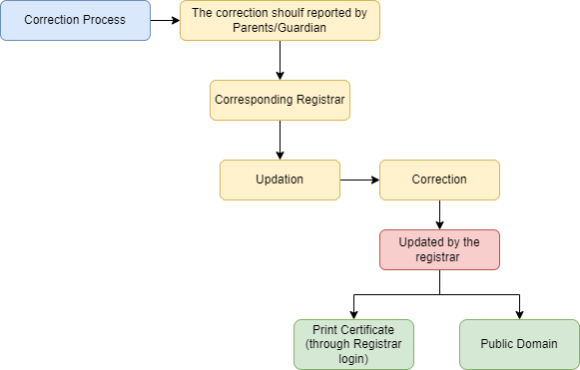
- Date correction
- Registrar can correct the date using date correction option available in Registrar login for Birth, Death registered records.
- The date correction request moved to AD login for approval.

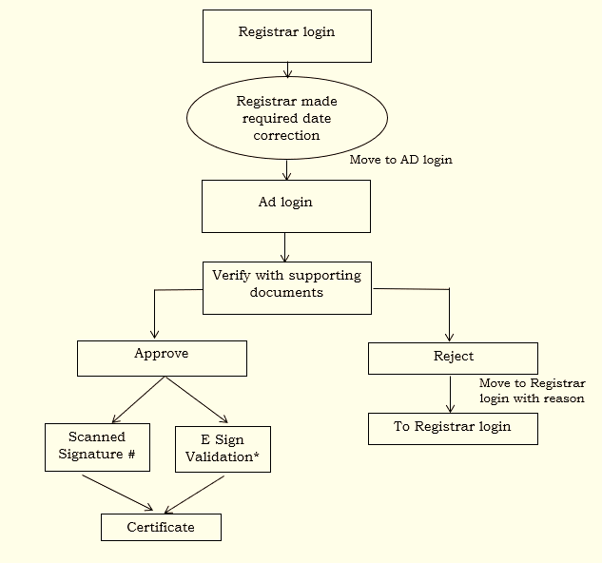
- Issue of Birth Certificate for single parent / unwed mother
If a Single parent / unwed mother applies for the issuance of a Birth Certificate for a child born from her womb, the Birth and Death Registrars concerned may only require her to furnish an affidavit to this effect, and must there upon issue the Birth Certificate, unless there is a Court direction on the contrary. In such cases the name of the single parent will be written in the birth record and the name of the other parent will have to be left blank.
- Procedure for registration of birth of Orphan/abandoned children
The in-charge or caretaker of the concerned institution in case of children in orphanage or similar institution and the guardian in case of children outside such institutions are responsible for reporting the birth event to the concerned Registrar of births and deaths under Section 8 of the Registration of Births and Deaths, (RBD) Act,1969.
  - In case the place of birth of the orphan child is not known, the place where the orphanage is located or the child is residing may be treated as the place of birth of the child.
  - In case the date of birth of the child is not known, the age may be determined by the Chief Medical Officer (CMO) having jurisdiction over the area where the orphanage is located or the child is residing and a probable date of birth assigned. The date of birth as assigned by the CMO can be taken as the date of birth and entered in the Birth Reporting Form.
  - In case the name(s) of parent(s) are known to in-charge of the institution/guardian, enter the same in the birth reporting form. In case the name(s) of parent(s) are not known, the column for name(s) of parent(s) shall remain blank in birth reporting form.
  - If the child is admitted through Surrender Deed, the respective orphanage should obtain birth certificate from the parents concerned in order to avoid duplication. If birth was not registered earlier, the orphanage shall report the details of the child for birth registration as mentioned above.
  - In case the name of the child is known, the same may be given in the Birth Reporting Form. In case the name is not known, the person in charge of the orphanage/guardian shall give a name to the child and record the same in the Birth Reporting Form.
  - In cases of delayed Registration, the procedure as laid down in Section 13(1), (2) and (3) and corresponding Rule 9 may be followed.
  - The concerned Registrar of Births and Deaths having jurisdiction over the area where the orphanage is located or where the orphan is residing shall register the birth based on the particulars provided in the Birth Reporting Form.
- Purpose of Death Registration:
The first section of the business requirement documentation should clearly define the purpose of death registration in CRS Tamil Nadu. This includes highlighting the significance of death registration for legal, statistical, and administrative purposes. The purpose may include:
Legal proof of death: Death registration provides legal proof of a person's demise, which is essential for various legal procedures such as inheritance, property transfer, insurance claims, etc.
Vital statistics: Accurate death registration helps in maintaining vital statistics related to mortality rates, causes of death, and demographic data. This information is crucial for public health planning and policy formulation.
Administrative records: Death registration assists in maintaining administrative records related to population management, social welfare programs, electoral rolls, etc.
- Death Registration
Death registration in the Civil Registration System (CRS) of Tamil Nadu is a crucial aspect of ensuring accurate and efficient recording of deaths in the state. This documentation serves as a guide for the development and implementation of the CRS, outlining the necessary features, functionalities, and processes required to facilitate death registration.
The deaths are reported at the place of occurrence of the event by the concerned institution/registrar under whom jurisdiction the event has taken place as per provision of Section 7 (2) of the RBD Act, 1969.
The institutional events cannot be reported by the family members, it is duty of the in-charge of the institution to report such events to concerned registrar.
In respect of death occurred in a Hospital, Health centre, Maternity or nursing home or other such institutions, the medical officer In-charge or any person authorized by him in this behalf is responsible for reporting.
In respect of death occurred in a house, it is the duty of the Head of the house/household or nearest relative of the head present in the house or in the absence of any such person, the oldest male person present therein during the said period is responsible to report the event to the concerned Registrar.
In respect of any new born child abandoned or dead body found deserted in a public place, the Village Administrative Officer in the case of a village and the officer in charge of the local police station elsewhere is responsible for reporting.
If death occurred in a moving vehicle, it should be reported by the family members or attendant accompanying the deceased and the event is to be reported to the Jurisdictional Registrar for registration.
The Death occurred in a moving vehicle transporting a patient should not be treated as institutional death despite the fact that patient was taken to nearby hospital and declared brought dead by the hospital. The Medical Officer is not responsible for reporting such deaths.
It cannot be the hospital name and address or the way to hospital etc. It will be registered by the Registrar in whose jurisdiction the area falls.
In case of natural death in a moving vehicle, in addition to vehicle in charge, if deceased was accompanied by relatives or attendant, they may report the event to the concerned Registrar in whose area the event occurred. In case deceased was not accompanied by any one, the vehicle in charge should report the event to the concerned Registrar in whose area the event occurred.
In case of accident, murder etc. (where an inquest is held) it will be covered under Rule 6(2) and will be registered on the basis of the Police inquest report and the Death report form furnished by them. The place of death will be the same as mentioned in that report.
In case of long journey, the first place of halt will be the place of death, in addition to vehicle in charge, if deceased was accompanied by relatives or attendant, they may report the event to the concerned Registrar in whose area the event occurred. In case deceased was not accompanied with any one, the vehicle in charge should report the event to the concerned Registrar in whose area the event occurred.
The normal period of 21 days (from the date of occurrence) has been prescribed for reporting the birth, death and still birth events.
If event of death is not reported for registration within 21 days, the same can be reported any time under the Delayed Registration provisions prescribed under Section 13 of the Act with payment of fee prescribed.
The concerned Registrars are to be approached at the place of occurrence of the event are
- Corporation - Sanitary Inspector
- Municipality, Township - Sanitary Inspector
- Town Panchayats - Executive Officer/ Sanitary Inspector
- Village Panchayats - Village Administrative Officer
- Primary Health Centres - Health Inspector
- Govt. Medical Institutions - Health Inspector
- Cantonment - Sanitary Inspector
- Estates / Plantations – Manager
- Death Registration of a Missing person
For Registration of deaths, information on date of death and place of death of a person is required. However, in case of a missing person her/his death is presumptive where the actual date of death and place of death cannot be ascertained. Ordinarily, a person un heard of for the statutory period shall be presumed to be dead on expiry of 7 years and not earlier.
- Still Birth
This information will normally be available from the hospital and other medical institutions. In case of domiciliary events enter only if known, otherwise write ‘Not Known’.
This provides information for ranking and analysing the conditions leading to still birth. When co-related with duration of pregnancy and age of mother gives good insight into the reproductive health status
Work process
- The events occurred in Institution has been reported in hospital through Institution login.
- All the events may be entered through registrar login also.
- The reported record which is send to corresponding registrar for validation purpose through Registrar login.
- For special cases, the following conditions not satisfied events will be moved to AD login such as RCH ID not entered.
- Finally, the registered record (Still-Birth certificate) moved to Public domain and download the certificates.

- Roles and Responsibilities of Registrar for Birth & Death registration
The Registrar of Birth and Death has been assigned immense responsibilities under the Registration of Birth and Deaths Act, 1969. No other person above the Registrar in the registration hierarchy can perform or take over the specific legal responsibilities cast upon her/him by the Act. The Registrar also has to comply with the Statistical functions assigned to her/him under the law. It is therefore, extremely crucial for the Registrar to inform herself/himself carefully about all the provisions of RBD Act and the corresponding State Rules so as to enable her/him to effectively and efficiently discharge the duties and responsibilities as per the provisions of the Act. The main roles and responsibilities of the Registrar can be broadly listed as follows.
a. To register all the vital events according to established methods and procedures under the Act.
b. To ensure compliance with the provisions of the RBD Act, 1969 and corresponding State Rules and the instructions issued by the Chief Registrar and District Registrar in this regard.
c. To ensure the accuracy and completeness of each record.
d. To take steps to inform himself carefully of all the events which take place within her/his jurisdiction and to ascertain and register all such events
e. To adopt such measures as are required to inform the public of the necessity, procedures and requirements of registration and value of vital statistics.
f. To issue certificate of birth/death as soon as the registration is completed and also at a later point of time, whenever a request is made.
g. To prepare and submit the statistical reports with in such time, at such intervals and in such manner and to such person as specified in the State Rules.
h. To keep safe custody of the record until the same are transferred to such office as specified and at such interval as specified in the State Rules.
The Registrar should maintain a list of institution falling within his/her jurisdiction from where births reports are to be received. She/He should be in touch with these institutions to ensure timely and accurate reporting of births.
The Registrar should make a list of persons made responsible for collecting reports of domiciliary births and deaths from the households where such events occur. She/He should be in touch with these persons and ensure that timely and accurate reports are received. (Here the exact designations of the officials may be included e.g. ANMs, Dais, Anganwadi Worker etc.,)
The Registrar will receive the filled-in forms from the hospitals, medical or other institutions and from the individual informants, directly or through notified officials. She/He should carefully check each of the forms for its completeness and accuracy. She/He should ensure that the entries made in the form, particularly in the Legal part, are legible and without any cutting or overwriting, as this would be the permanent document. Any of the entries made in the Legal part of the form should not spill over to the Statistical part. If any of the above-mentioned insufficiencies are noticed in the form, it should not be accepted and forthwith returned to the institution or the notified official for appropriate correction and if necessary, for re-filling.
After having satisfied himself with the proper completion of the forms and after the due process of verification of the veracity of the event, wherever needed, the registrar should register the event. Before registering the event she/he should also make sure that the event reported has actually occurred within her/his jurisdiction. She/He then has to enter the Registration Number and the Registration Date in the space provided in both parts (Legal and Statistical part) of the reporting form and enters her/his name and signature therein. This would complete the process of registration. In case of multiple births, the informant should fill in separate form for each child. The Registrar should make a note of this in the Remarks column in the box at the bottom of the legal part of the birth report form and write ‘Twin birth;’ or ‘Triple birth’ as the case may be. After the registration process the Registrar has to validate the entries forwarded to his/her login. The Registrar has a right to validate the entries according to the Act.
For special cases while registering the Birth if the following conditions are not satisfied the event will be moved to AHO login in respect of Chennai District and to AD login Other than Chennai District such as
- RCH ID not entered in Birth Reporting Form
- Low Birth weight
- Pre-matured baby
- Pregnancy weeks ( below or above the normal gestation period)
For special cases while registering the Death if the following conditions are not satisfied the event will be moved to AHO login in respect of Chennai District and to AD login Other than Chennai District such as
1. RCH ID not entered in Death Reporting Form for Maternal Death & Infant Death
2. Deceased Reported with communicable and notifiable diseases and misclassified cause of death.
3. In case of Institutional deaths cause of death it shall be reported in e-Mor Software integrated with CRS Software by the Medical Institutions then only the death could be registered.
4. For Non-Institutional Deaths the cause of death has to be ascertained by the Birth and Death Registrar from the informants/Relatives of the deceased and shall enter the e-Mor Software for Registering the death.
After validation, If the respective Registration Unit comes under e-sign certified unit then registrar the e-sign validation procedure through C-DAC adhar validation and the Registration of the events is moved to public domain. The Registration Units under Primary Health Centres, TP, Municipality, Corporation, Project Area are e-sign certified moved to public domain with scanned signature of concerned Registrar. From the Public Domain Birth certificate can be downloaded.

Birth & Death Registration
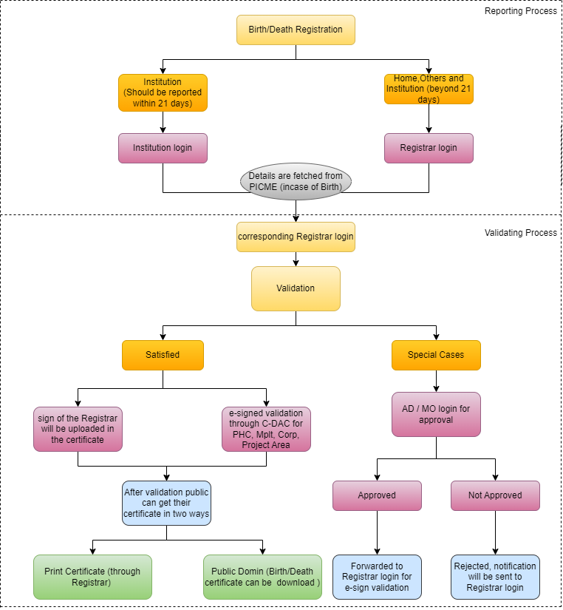
- Delayed Registration
In some cases, if the information has not been provided within the prescribed time limit, the Births/Death could be registered up on payment of late fee and orders of the prescribed authority. The Jurisdictional Birth and Death Registrar may be approached for getting details towards registration.
In case, any child born outside India, his/her birth would be registered under the Citizenship Act 1955 and Citizens (Registration at Indian consulates) Rules, 1956 at the Indian Missions.
The Indian Consulates register the births and deaths of the Indian Citizens occurring outside India as per the provisions made in the Citizens (Registration of India Consulate) Rules, 1956 under the Citizenship Act 1955and issue the birth and death certificates. Under section 20(2) of the RBD act, the Indian Citizens have also been allowed to register the births of their children at the place of their usual residence within 60 days after their return to India if they return with a view to setting here. If this birth cannot be registered within 60 days, the same can be registered under the delayed registration provisions of section 13 (2) & (3) of the said Act. After expiry of the aforesaid period, the provisions of the Section 13(3) of the Act will be applicable. Registration of death is not covered under Section 20(2). The Section 20(1) of the RBD act provides that the Registrar General, India subject to the Rules made in this behalf, cause to be registered the information of such births and deaths received by him under the Citizens (Registrations at India Consulate) Rules, 1956 and those under Section 20(2) of the RBD Act would take care of registrations of all such events and hence it would not be necessary to frame any Rule on the subject
Registration of an event of which information is given to the Registrar after the expiry of the prescribed period but within 30 days of its occurrence, is done on the payment of the late fee. Registration of an event of which information is given to the Registrar after 30 days but within one year of its occurrence is registered on payment of a prescribed fee, shall be registered only with written permission of the officer prescribed behalf on payment of late fee prescribed.
Any Birth or Death event which has not been registered within 1 year of occurrence shall be registered only on the order passed by the Executive Magistrate / RDO upon paying the prescribed fee.
Reporting Period | Fee details
After 21 days (Between 21 days to 30 days) | Rs.100/-
After 30 days (Between 30 days to 1 year) | Rs.200/-
After 1 year | Rs.500/-

- Registration of Adopted Child
Adoption procedures have been made simple and a new form for registering adopted children has been introduced (Form1A) and the Birth certificate to the adopted child is issued in Form No.5 (Birth Certificate) containing the name of the adopted parents and the place of birth will be taken as name of the city /place where the agency / institution giving adoption is situated and the registrar will register the adopted child based on the adoption and the registered adoption deed.
For non-institutional adoptions that took place within relations or acquaintances registered adoption deed duly registered before the sub registrar authorized by the State Government is enough and no need to produce adoption order of a court for such cases.
If the adoptions taking place through institution the details of the parents may or may not be known and the birth of the child may or may not be registered. The matter of registration of birth of a child taken on adoption and issuance of certificate thereof may be referred to the guidelines issued by the Government in this regard. This guideline has also been given in the ‘Handbook on Civil Registration’.
Work Flow
  - All the events may be entered through registrar login.
  - The reported record which is send to corresponding registrar for validation purpose through Registrar login.
  - All the events moved to AD login for verification purpose.
  - If the respective Registration Unit comes under e-sign certified then registrar undergoes the e-sign validation procedure through C-DAC Aadhar validation.
  - Other than e-sign Registration Unit, the certificate moved to public domain with scanned signature of concerned Registrar.
  - Finally, the registered record (Birth certificate) moved to Public domain and download the certificates.
- Rules for Tamil Nadu Registration of Births and Deaths
THE TAMIL NADU REGISTRATION OF BIRTHS AND DEATHS RULES 2000
ARRANGEMENTS OF RULES –
As per the HEALTH AND FAMILY WELFARE DEPARTMENT
No. SRO A-95(a)/99

In exercise of the powers conferred by section 30 of the Registration of Births and eaths Act, 1969 (Central Act 18 of 1969) and in the suppression of the Tamil Nadu Births and Deaths Registration Rules, 1977, the Governor of Tamil Nadu with the approval of the Central Government hereby makes the following rules, namely Short title, extent and commencement:
(1) These rules may be called the Tamil Nadu Registration of Births and Deaths Rules, 2000.
  - These rules shall extend to the whole of the State of Tamil Nadu.
  - They shall come into force on the 1st January 2000.
Definitions :-
In these rules, unless the context otherwise requires:
(a) “Act” means the Registration of Births and Deaths Act, 1969 (Central Act 18 of 1969) (b)“Form” means a Form appended to these rules,
- “Government” means the State Government,
- “Section” means a section of the Act.
- “Register” means Register of Births and Deaths.
Period of Gestation: The period of gestation for the purposes of clause (g) of sub- section (1) of section 2 shall be twenty-eight weeks.
Submission of report under sub-section (4) of section 4 :– [The report under sub-section shall be prepared in the prescribed format appended to these Rules and shall be submitted along with the statistical report referred to in sub-section (2) of section 19, to the State Government by the Chief Registrar for every year by the 31st July of the year following the year to which the report relates].
Form for giving Information of births and deaths: (1) The information required to be given to the Registrar under section 8 or section 9, as the case may be, shall be in [Forms Nos.1, [1A,2 and 3] for the Registration of a birth, adoption of child, death and still birth respectively, herein after to be collectively called the reporting forms. Information, if given orally shall be entered by the Registrar in the appropriate reporting form and the signature or thumb impression of the informant obtained.
The part of the reporting form containing legal information shall be called as “Legal Part” and the part containing statistical information shall be called as “Statistical Part”.
The information referred to in sub-rule (1) shall be given within twenty one days from the date of birth, death or still birth.
- The expression were substituted for the expression “Form 16”
- The expression were substituted for the expression “Form 2, 3 and 4”
vide G.O.Ms.No.85 Health &Family Welfare (AB2) Department, dt.29.04.2003
- The expression “Form 1A” included.
vide G.O.Ms.No.226 Health &Family Welfare (AB2)Department, dt.06.08.2015.
The reporting forms (1,1A, 2 and 3) were amended in vide G.O.D.No.1322 Health and Family Welfare Department dated: 06.12.2006, G.O.(Ms)No.409 Health and Family Welfare (AB2) Department dated: 16.12.2014, G.O.(Ms)No.37 Health and Family Welfare (AB2) Department dated: 11.02.2015 , G.O.(Ms)No. 257 Health and Family Welfare (AB2) Department dated: 25.08.2015, G.O.(Ms)No.177 Health and Family Welfare (AB1) Department dated: 30.06.2016, G.O.(Ms)No.384 Health and Family Welfare (AB2) Department dated: 27.08.2019
Death in a vehicle:
(1) In respect of a birth or death in a moving vehicle, the person in-charge of the vehicle shall give or cause to be given the information under sub- section (1) of Section 8 at the first place of halt.
Explanation : For the purpose of this rule, the term “Vehicle” means conveyance of any kind used on land, air or water and includes an aircraft, boat, ship, railway carriage, motor-car, motor – cycle, cart, tonga and rickshaw.
  - In the case of deaths (not falling under clauses (a) to (e) of sub-section (1) of section 8) in which an inquest is held, the officer who conducts the inquest shall give or cause to be given the information under sub-section (1) of section 8.
Notification and Form of Certificate under section 10:
(1) The certificate as to the cause of death required under sub-section (3) of section 10 shall be issued in ¹[Form No.4 or 4A] and the Registrar shall, after making necessary entries in the Register of Births and deaths, forward all such certificates to the Chief Registrar or the Officer specified by him in this behalf by the 10th of the month immediately following the month to which the certificate relates
(2) Any person who performs the funeral ceremonies of a person dying in a local area within the jurisdiction of a municipality, panchayat or other local authority or any other area, shall whenever required furnish to the Registrar such information as he possesses regarding the particulars required for registration.
Extracts of registration entries to be given under section 12:
The extracts of particulars from the register relating to births or deaths to be given to an informant under section 12 shall be in [Form No.5 or Form No. 6] as the case may be.
In the case of domiciliary events of births and deaths referred to in clause (a) of sub- section (1) of section 8, which are reported direct to the Registrar of Births and Deaths, the head of the house or household as the case may be, or in his absence, the nearest relative of the head present in the house may collect the extracts of birth or death from the Registrar within 30 days of its reporting.
In the case of domiciliary events of births and deaths referred to in clause (a) of sub- section (1) of section 8 which are reported by persons specified by the State Government under sub-section (2) of the said section, the person so specified shall transmit the extracts received from the Registrar of Births and Deaths to the concerned head of house, or household, as the case may be, or in his absence the nearest relative of the head present in the house within thirty days of its issue by the Registrar.
In the case of institutional events of births and deaths referred to in clauses (b) and (e) of sub-section (1) of section 8, the nearest relative of the new born or deceased may collect the extract from the officer or person in-charge of the institution concerned within thirty days of the occurrence of the event of birth or death.
If the extract of birth or death is not collected by the concerned person as referred to in sub-rules (2) to (4) within the period stipulated therein, the Registrar or the officer or person in-charge of the concerned institution as referred to in sub-rule (4) shall transmit the same to the concerned family by post within fifteen days of the expiry of the aforesaid period.
Authority for delayed registration and fee payable thereof under section 13:
When the informant declares the particulars of an event after the expiry of the prescribed period, the registration of such an event is governed by the provisions regarding delayed registration under section 13 of the Act and the relevant rules made there under.
Any birth or death of which information is given to the Registrar after the expiry of the period specified in rule 5, but within 30 days of its occurrence shall be registered on payment of a late fee of rupees one hundred.
Any birth or death of which information is given to the Registrar after thirty days but within one year of its occurrence, shall in the case of the local authorities specified in column (1) of the Table below, be registered only with the written permission of the officers specified in the corresponding entries in column (2) thereof, on payment of a late fee of [rupees two hundred].
Local Authorities | Officer
Village Panchayat | Village Panchayat President
Town Panchayat | Executive Officer
Cantonment | Executive Officer
Municipality | Commissioner
Corporation | Commissioner
Neyveli Lignite Corporation | Chief Health Officer

Any birth or death which has not been registered within one year of its occurrence shall be registered by an order of the Executive Magistrate not below the rank of a Revenue Divisional Officer] and on payment of late fee of [rupees Five hundred].
Any person aggrieved by any order made under sub-rule 2, by the officers specified in column (1) of the Table below may, within one month from the date of receipt of such order, prefer an appeal against such order to the authorities specified in the corresponding entries in column (2) thereof.
Local Authorities  (1) | Officers (2)
Village Panchayat President | Revenue Divisional Officer
Executive Officer | Revenue Divisional Officer
Revenue Divisional Officer | District Collector
Executive Officer, Cantonment | District Collector
Commissioner of Municipality | District Collector
District Collector | Chief Registrar of Births and Deaths
Commissioner of Corporation | Chief Registrar of Births and Deaths
Chief Registrar of Births and Deaths | Government

Provided that the appellate authority may in its discretion allow further time not exceeding one month for preferring any such appeal if it is satisfied that the appellant has sufficient cause for not preferring the appeal in time.
Period for the purpose of Section 14: (1) Where the birth of any child had been registered without a name, the parent or guardian of such child shall, within 12 months from the date of registration of the birth of child, give information regarding the name of the child to the Registrar either orally or in writing.
Provided that if the information is given after the aforesaid period of 12 months but within a period of 15 years which shall be reckoned:
    - in case where the registration had been made prior to the date of commencement of the Tamil Nadu Registration of Births and Deaths Rules, 2000 from such date, or
    - in case where the registration is made after the date of commencement of the Tamil Nadu Registration of Births and Deaths Rules, 2000 from the date of such registration, subject to provisions of sub – section (4) of section 23.
If the register is in his possession forthwith enter the name in the relevant column of the concerned form in the birth register on payment of a late fee of rupees two hundred.
If the register is not in his possession and if the information is given orally, make a report giving necessary particulars, and, if the information is given in writing, forward the same in the case of the local authorities specified in column (1) of the Table below to the officers specified in the corresponding entries in column (2) thereof for making necessary entry on payment of a late fee of ²[rupees two hundred]

Local Authorities (1) | Officers (2)
Village Panchayat | Village Panchayat President
Town Panchayat | Executive Officer
Contonment | Executive Officer
Municipality | Commissioner
Neyveli Lignite Corporation | Chief Health Officer
Corporation | Commissioner

The parent or the guardian, as the case may be, shall also present to the Registrar the copy of the extract given to him under section 12 or a certified extract issued to him under section 17 and on such presentation the Registrar shall make the necessary endorsement relating to the name of the child or take action as laid down in clause (b) of the sub-rule (1)

Correction or cancellation of entry in the register of births and deaths under section 15
If it is reported to the Registrar that a clerical or formal error has been made in the register or if such error is otherwise noticed by him and if the register is in his possession, the Registrar shall enquire into the matter and if he is satisfied that any such error has been made, he shall correct the error (by correcting or canceling the entry) as provided in section 15 and shall in the case of local authorities specified in column (1) of the Table below send an extract of the entry showing the error and how it has been corrected to the officer specified in column 2 thereof.

Local Authorities  (1) | Officers  (2)
Village Panchayat | Village Panchayat President
Town Panchayat | Executive Officer
Contonment | Executive Officer
Municipality | Commissioner
Neyveli Lignite Corporation | Chief Health Officer
Corporation | Commissioner

In the case referred to in the sub-rule (1) if the register is not in his possession, the Registrar shall make a report to the officer specified in the table in sub-rule (1) and call for the relevant register and after enquiring into the matter, if he is satisfied that such error has been made, necessary correction.
Any such correction as mentioned in sub-rule (2) shall be countersigned by the officer specified in the Table in sub-rule (1) in this behalf when the register is received from the Registrar.
If any person asserts that any entry in the register of births and deaths is erroneous in substance, the Registrar may correct the entry in the manner prescribed under section 15 upon production by that person a declaration setting forth the nature of the error and true facts of the case made by two credible persons having knowledge of the facts of the case.
Notwithstanding anything contained in sub-rules (1) and (4), the Registrar shall make a report of any correction of the kind referred to therein giving necessary details to the officer specified in the table in sub-rule (1).
If it is proved to the satisfaction of the Registrar that any entry in the register of births and deaths has been fraudulently or improperly made, he shall make a report giving necessary details to the officer authorized by the Chief Registrar by general or special order in this behalf under section 25 and on hearing from him take necessary action in the matter.
In every case in which an entry is corrected or cancelled under this rule, intimation thereof should be sent to the permanent address of the person who has given information under section 8 or section 9.
Form of register under section 16
The legal part of the [Form Nos. 1, 2 and 3 shall be the Form No. 7, 8 and 9 and shall constitute the birth register, death register and still birth register respectively.]

From 1st January of each calendar year new registration number starting from 1 should be followed and continues till 31st December of that year.
An event which occurred in any previous year reported during the current year shall be recorded in the current year register only.
A control register in [Form No.14A] shall be maintained by the Tahsildar to watch receipt of returns from all registration units in the area and dispatch of the same to the Chief Registrar or to the officer specified by him in this behalf.
Provided that no fee shall be payable by any officer of the Government of Tamil Nadu or by any member of the staff of Estate duty circles duly authorized by their officers or by any person duly authorized by the District Soldiers, Sailors and Airmen’s Board for searching or for obtaining an extract or for giving non-availability certificate of birth or death from any registrar for a bonafide public purpose, including the investigation of pension claims from families of deceased Indian Military Personnel. Any such extract in regard to a birth or death shall be issued in [Form No.5 or in Form No.6] as the case may be and shall be certified in the manner provided for in section 76 of the Indian Evidence Act, 1872, (Act 1 of 1872), in the case of local authorities specified in column (1) of the table below by the Registrar or the Officers specified in the corresponding entries in column (2) thereof:
Local Authorities (1) | Officers (2)
Village Panchayat  Town Panchayat | Village Panchayat President and Executive Officer (till the expiry of two years after the close of the calendar year to which the register relates).  Sub-Registrar of Assurance (after the expiry of two years).
Contonment | Executive Officer
Municipality | Commissioner
Corporation | Commissioner
Neyveli Lignite Corporation | Chief Health Officer

If any particular event of birth or death is not found registered, the Registrar or the officers specified in column 2 of the Table under sub-rule 2 shall issue a non-availability certificate in [Form No.10]. Any such extracts or non-availability certificate may be furnished to the person asking for it or sent to him by post on payment of the postal charges there for.
Interval and forms of periodical returns under sub-section (1) of section 19
Every Registrar shall after completing the process of registration send all the statistical parts of the reporting forms relating to each month along with a summary monthly report in Form No.11 for Birth, Form No.12 for deaths, and Form No.13 for Still Births to the Chief Registrar or the officer specified by him in this behalf on or before the 5of the following month. The officer so specified shall forward all such statistical parts of the reporting forms received by him to the Chief Registrar or the officer specified by him, not later than 10th of that month.
Statistical report under sub-section (2) of section 19
The Statistical report under sub- section (2) of section 19 shall contain the tables in the prescribed formats appended to these rules and shall be compiled for each year before the 31st July of the year immediately following and shall be published as soon as may be thereafter but in any case not late that five months from that date.
Conditions for compounding offences under section 23
Any offence punishable under section 23 may, either before or after the institution of criminal proceeding under this Act, be compounded by an officer authorized by the Chief Registrar by a general or special order in this behalf, if the officer so authorized is satisfied that the offence was committed through inadvertence or oversight or for the first time.
MODE of payment of fees
All fees payable under the Act may be paid in cash or money order or postal order.

- Step by step Procedure for downloading Birth / Death certificates
- Go to CRS web portal URL https://crstn.org/birth_death_tn/ in the web browsers Google Chrome, Firefox etc.,
- Click the certificate download menu in the home page of the CRS web portal.
- On clicking the above, the options Birth and Death will appear.
- To download the Birth certificate, select Birth and enter the following details.
- Either RCH ID or Gender, District, Place of Birth and Date of Birth
- To download the Death certificate, select Death and enter the following details.
- Gender, District, Place of Death and Date of Death
- Enter Mobile number of the applicant.
- Enter the verification number
- Then click view
- The list of births/ death registered on the selected Date and place will appear
- select the required Birth/ Death certificate and download the same.

